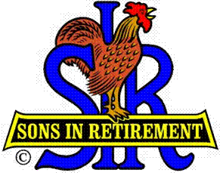

Las Trampas Branch 116

Executive Committee Meeting Agenda

November 19, 2018
9:30 AM
- Call Meeting to Order and confirm we have a quorum.
- Review Agenda/Minutes for Changes/Additions.
- Standing Reports:
Secretary – Fred Schafer – Approval of October 15, 2018 minutes
Attendance – Kevin Donahue, NEED A REPLACEMENT
Head count, missed luncheon receipts
Membership – Phil Goff
New Members:
Guests Today:
Visitors:

- Budget – Jim Nickels

- Big Sir Report:
- Story Teller: Big SIR Marty Katz
- Chaplain: Big SIR Marty Katz
- Veterans Presentation
- Certificates of Achievement

- Little Sir Report:
- November Speaker: Colonel Chris Starling, United States Marines, Retired
- Other

- Other Reports & Discussion:

- Adjourn – 10:15 am

